Coverage Criterion: Edge Coverage
Objective:
The test cases are designed to execute every transition (edge) in the Taiga User Registration/Login control flow graph at least once.
Graph-Based Test Cases:
Test ID | Scenario | Path Through Graph Nodes | Input Condition | Expected Result | Actual Result | Status
GB-01 | Valid Registration | 1 → 2 → 3 → 4 → 5 → 6 → 7 → 8 → 16 | Valid username, valid email, valid password, valid full name | Account is created successfully and registration completes
GB-02 | Invalid Username During Registration | 1 → 2 → 3 → 4 → 9 → 16 | Username is invalid or already exists | Registration is rejected
GB-03 | Duplicate Email During Registration | 1 → 2 → 3 → 4 → 5 → 9 → 16 | Username valid, email already exists | Registration is rejected
GB-04 | Password Policy Failure | 1 → 2 → 3 → 4 → 5 → 6 → 9 → 16 | Password does not meet required policy | Registration is rejected
GB-05 | Valid Login | 1 → 2 → 10 → 11 → 12 → 13 → 15 → 16 | Existing active user enters correct password | User is authenticated and login succeeds
GB-06 | Inactive Account Login | 1 → 2 → 10 → 11 → 14 → 16 | User account exists but is inactive | Login is rejected
GB-07 | Incorrect Password Login | 1 → 2 → 10 → 11 → 12 → 14 → 16 | Existing user enters incorrect password | Login is rejected

Graph Edge Coverage Mapping:
Edge | Covered By Test Case
1 → 2 | GB-01, GB-05
2 → 3 | GB-01
2 → 10 | GB-05
3 → 4 | GB-01
4 → 5 | GB-01
4 → 9 | GB-02
5 → 6 | GB-01
5 → 9 | GB-03
6 → 7 | GB-01
6 → 9 | GB-04
7 → 8 | GB-01
8 → 16 | GB-01
9 → 16 | GB-02, GB-03, GB-04
10 → 11 | GB-05
11 → 12 | GB-05
11 → 14 | GB-06
12 → 13 | GB-05
12 → 14 | GB-07
13 → 15 | GB-05
14 → 16 | GB-06, GB-07
15 → 16 | GB-05

Graph-Based Test Execution Results:
Test ID | Expected Result | Actual Result | Pass/Fail | Defect Found
GB-01 | Account created successfully | Returned true, and account creation completed successfully | Pass | No defect found
GB-02 | Registration rejected | Returned false and invalid username was rejected | Pass | No defect found
GB-03 | Registration rejected | Returned false and duplicate email was rejected | Pass | No defect found
GB-04 | Registration rejected | Returned false and weak password was rejected | Pass | No defect found
GB-05 | Login successful | Returned true and access was granted | Pass | No defect found
GB-06 | Login rejected | Returned false and inactive account was denied access | Pass | No defect found
GB-07 | Login rejected | Returned false and incorrect password was rejected | Pass | No defect found

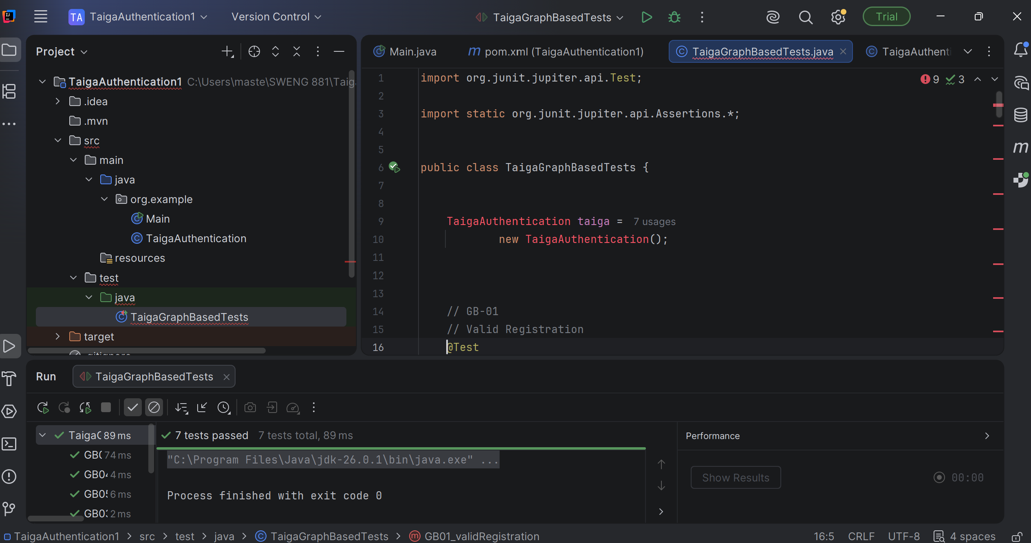The illustration above demonstrates that the graph-based test cases were executed using JUnit 5 in IntelliJ IDEA. All seven test cases passed, demonstrating that the selected Edge Coverage criterion was achieved by exercising all major registration and login decision branches.

